**SANDES A CHAT APPLICATION**

**A PROJECT REPORT**

***Submitted By***

**KOTHDIA JAY [18BECE30074]**

**JASANI KULDIP [18BECE30091]**

**MENDAPARA SMIT [18BECE30167]**

***In fulfilment of the award of the degree***

***Of***

**BACHELOR OF ENGINEERIG**

**In**

**COMPUTER ENGINEERING**



**LDRP INSTITUTE OF TECHNOLOGY AND RESEARCH,**

**GANDHINAGAR**

**Kadi Sarva Vishwa Vidhyalaya**

**NOVEMBER 2021**

**LDRP Institute of Technology and Research**

**GANDHINAGAR**

CE-IT DEPARTMENT



**CERTIFICATE**

This is to certify that the Project Work entitled **“Sandes A Chat Application”** has been carried out by **Kothdia Jay Pareshkumar (18BECE30074)** under my guidance in fulfilment of the degree of Bachelor of Engineering in Computer Engineering Semester-7 of Kadi Sarva Vishwavidyalaya University during the academic year 2021-22.

Jayana Kaneriya Dr. Shivangi Surati

**Internal Guide Head of Department**

**LDRP-ITR LDRP-ITR**

**LDRP Institute of Technology and Research**

**GANDHINAGAR**

CE-IT DEPARTMENT



**CERTIFICATE**

This is to certify that the Project Work entitled **“Sandes A Chat Application”** has been carried out by **Jasani Kuldip Maheshbhai (18BECE30091)** under my guidance in fulfilment of the degree of Bachelor of Engineering in Computer Engineering Semester-7 of Kadi Sarva Vishwavidyalaya University during the academic year 2021-22.

Jayana Kaneriya Dr. Shivangi Surati

**Internal Guide Head of Department**

**LDRP-ITR LDRP-ITR**

**LDRP Institute of Technology and Research**

**GANDHINAGAR**

CE-IT DEPARTMENT



**CERTIFICATE**

This is to certify that the Project Work entitled **“Sandes A Chat Application”** has been carried out by **Mendapara Smit Ashokbhai (18BECE30167 )** under my guidance in fulfilment of the degree of Bachelor of Engineering in Computer Engineering Semester-7 of Kadi Sarva Vishwavidyalaya University during the academic year 2021-22.

Jayana Kaneriya Dr. Shivangi Surati

**Internal Guide Head of Department**

**LDRP-ITR LDRP-ITR**

**Acknowledgment**

We take this opportunity to humbly express our thankfulness to all those concerned with our project.

First of all we are thankful to **LDRP-ITR** for undertaking this project. We are sincerely indebted to **Mrs.** **Jayana Kaneriya** for giving us the opportunity to work on this project. Her continuous guidance and help have proved to be a key to our success in overcoming the challenges that We have faced during our project work. Her support made the project a pleasantly memorable one. Without her help at all stages in spite of her own workload; the completion of the project would not have been possible.

There are so many people without whose help We would never have conceived and learnt, to whom We would like to express our gratitude – our friends, colleagues, and of course the CE & IT Department of LDRP-ITR.

Last but not least We are thankful to almighty GOD and our PARENTS for giving us such a good atmosphere to work hard and to succeed.

**INDEX**

|  |  |
| --- | --- |
| **No** | **CHAPTER NAME** |
| **1** | **Introduction**  1.1 Project Profile  1.2 Project Summary  1.3 Project Purpose |
| **2** | **Project Management**  2.1 Project Planning & Scheduling  2.2 Risk Management |
| **3** | **System Requirement Study**  3.1 User Characteristic  3.2 Hardware Requirement  3.3 Software Requirement |
| **4** | **Tools and Technology**  4.1 Technology Study  4.2 Feasibility Study |
| **5** | **System Analysis and Design**  5.1 System Diagram  5.2 Use-case Diagram  5.3 Sequence Diagram  5.4 Activity Diagram |
| **6** | **Testing**  6.1 Testing Plan  6.2 Testing Strategy  6.3 Testing Method  6.4 Test Class |
| **7** | **Screenshots** |
| **8** | **Conclusion** |
|  |  |

# PREFACE

Project during the study is the bridge between theoretical and practical knowledge. The main objective of the project is to get details about the operation process being carried out within the company. Theory of any subject is important but without its practical knowledge, it becomes useless.

Practical training polishes the theoretical aspects of the technical studies. The aim is to open up the window of project knowledge to a student and give hint of an insight regarding the operations, processes and troubleshooting of a system.

|  |  |
| --- | --- |
| **1** | **INTRODUCTION** |
| 1.1  1.2  1.3 | Project Profile  Project Summary  Project Purpose |

* 1. **PROJECT PROFILE**

|  |  |
| --- | --- |
| **Project Title :** | Sandes A Chat Application |
| **Organization :** | LDRP INSTITUTE OF TECHNOLOGY AND RESEARCH |
| **Tools :** | * **Hardware**   + **Client:**   Android Smartphone  Active Internet Connection 256 MB of RAM   * + **Server:**   2 GHZ of CPU  4 GB of RAM  Active Internet Connection Monitor  Keyboard/Mouse   * **Software**   + **Client:**   OS : Android 7.0 or higher Development : Android,Java,XML   * + **Server:**   OS : Windows 10 Development : FIREBASE |
| **Starting Date :** | 25-7-2021 |
| **Ending Date :** |  |
| **Team Size :** | 3 Person |
| **Team Member:** | Jay P. Kothdia(18BECE30074)  Smit A. Mendapara(18BECE30167)  Kuldip M. Jasani (18BECE30091) |
| **Guided By:** | Jayana Kaneriya  Lecturer CE-IT Department |
| **Submitted To:** | DEPARTMENT OF COMPUTER ENGINEERING AND INFORMATION TECHNOLOGY  LDRP INSTITUTE OF TECHNOLOGY AND RESEARCH, GANDHINAGAR |

* 1. **PROJECT SUMMARY**

Our Project “Sandes-A Chat Application” as the name suggest is chatting based application through which different user can interact with each other.

The sole aim of making this project is to learn more about android and getting more familiar with different aspects of android development.

In this project we also have used **GOOGLE FIREBASE** which is a very important feature when it comes to data storage and various other services for development

In this app users will be able to send messages to each other and can set up their profile.

This app features an OTP based authentication through which the user can register on the app.

* 1. **PROJECT PURPOSE**

During the course of engineering a student must learn technologies and get more familiar with them by applying the learnings.

So as we wanted to learn more about Android and apply our skills we took up this project so that we would be able to learn more about Android and to be able to apply our skills at the same time.

Another benefit of this project is that, as we have used **Google Firebase,** we also got learn about new aspect in development

|  |  |
| --- | --- |
| **2** | **PROJECT MANAGEMENT** |
| 2.1  2.2 | Project Planning  2.1.1 Project Development Approach  2.1.2 Milestones and Deliverable  Risk Management |

* 1. **PROJECT PLANNING**

### Project Development Approach:

The model that is referred for the development of the project is INCREMENTAL model. It combines elements of the waterfall model applied in an iterative fashion. In this process the phases are the same as waterfall but the advantage is that when the first phase is done it is incremented and then the other phases are carried with the same cycle. Here in this add ones on each phase can be added according to the need of the client and the project.

Phases are as follows:

1. Communication
2. Planning

3.Modeling: Includes Designing

1. Construction
2. Deployment: Feedback,Delivery

Each phase is iteratively carried out. Main reason for using this then any other is waterfall has the drawback of iterations, if there is any other requirement added later on then this is not possible to add up in it, Spiral model has disadvantage that it need more manpower and even it is for multiple transactions or multiple tasks handling projects and so does the time consumption is more in it for those projects.

Planning is essential because multiple software teams work in parallel on different system functions. Scalability should be obtained in any of the projects selected but it is not available in waterfall cause of few drawbacks.

### Project Development Approach:

#### Month 1 : Milestones & Deliverable

|  |  |
| --- | --- |
| **Milestones** | **Deliverable** |
| Study about our application requirement, planning | Analysis Report |
| Understand project definitions and basic terms and logic for Parameter Evaluation. |
| Gathering the requirements of the project using different fact finding techniques. |
| Still Continue with Requirement’s study. |

**Month 2 : Milestones & Deliverable**

|  |  |
| --- | --- |
| **Milestones** | **Deliverable** |
| System analysis. | Analysis Report |
| System design including various diagrams. | SRS |

#### Month 3-4 : Milestones & Deliverable

|  |  |
| --- | --- |
| **Milestones** | **Deliverable** |
| Firebase account creation and setup. | NA |
| Setting up Firebase authentication. | NA |
| User registration via OTP based authentication. | Designing/Coding |
| Setting up user profile photo and name. | Designing/Coding |
| Setting up main Chat activity. | Designing/Coding |

**Month 5 : Milestones & Deliverable**

|  |  |
| --- | --- |
| **Milestones** | **Deliverable** |
| Application Testing. | Testing |
| Required changes after testing. | Final App |

## RISK MANAGEMENT

Identifying risk and drawing up plans to minimize their effect on the project is called risk management. Risk may threaten the project, the software that is being developed or the organization. These categories of risk can be defined as follow:

* Project Risks are risks, which affect the project schedule or resources.
* Product Risks are risks, which affect quality or performance of the software being developed.
* Business Risks are risks which affect the organization developing the software.

#### RISK IDENTIFICATION

The following are the possible risks, which are associated with the project. We have identified mainly technical and project risks.

**TECHNICAL RISK**

* + It cannot work if the proper system is not installed.
  + Our Application doesn't work for android 6.0 or below.
  + Location activity might not work on some devices.

**PROJECT RISK**

* + Scope might have been wrongly defined and the project might go in the wrong direction.
  + The time limits might not have been properly calculated as per the scope. If the project was not properly scheduled, or if the scope was ill defined, it might not be possible to finish the project at the right time. Scope creep could occur. The expectations and requirements have increased or may be changed.

#### RISK ANALYSIS AND PLANNING

* To handle the risks we have prioritized it. The damaging risks can be handled first and then most likely risks. Since the risk related to the schedule slippage arises primarily due to the intangible nature of the software, so we had to do the visibility of software requirements documentation and review the relevant documents during the developments. Every phase can be broken into the reasonably sized tasks and milestones can be scheduled for these tasks.
* In this process each identified risk is considered in turn and a judgment made about the probability and the seriousness of the risk.
* The probability of the risk might be assessed as very low (less than 10%), low (10-25%), moderate (25-50%), high (50-75%) or very high (greater than 75%).
* The effects of the risk might be assessed as catastrophic, serious, tolerable or insignificant.

|  |  |
| --- | --- |
| **3** | **SYSTEM REQUIREMENT STUDY** |
| 3.1  3.2  3.3 | User Characteristics  Hardware Requirements  Software Requirements |

* 1. **USER CHARACTERISTICS**

Analyzing user characteristics is an important aspect of any project. It allows us to clearly define and focus on who the end users are for the project. Also, it allows checking the progress of the project to ensure that we are still developing the system for the end users. The user must have following characteristics:

* + - Users should understand how the android system works.
    - Users should understand the use of all activity.
    - Users can easily interact with the proposed system.
    - Users must know the technical terms used in the company for performing different tasks specially related to his work, payment details, transportation details and report retrieval.
    - Users should also be aware about the running process of the system.

**3.2 HARDWARE REQUIREMENTS**

**Client:**

Android Smartphone

Active Internet Connection

2 GB of RAM

**Development:**

2 GHZ CPU

4 GB RAM

Active Internet Connection

Monitor

Keyboard /Mouse

**3.3 SOFTWARE REQUIREMENTS\**

**Client:**

OS: Android 7.0 or Higher

Development: Android

**Development:**

OS: Windows / Linux

Android Studio, Firebase

|  |  |
| --- | --- |
| **4** | **TOOLS AND TECHNOLOGY** |
| 4.1  4.2 | Technology Study  Feasibility Study |

* 1. **TECHNOLOGY STUDY**

#### JAVA

Java is a powerful general-purpose programming language. It is used to develop desktop and mobile applications, big data processing, embedded systems, and so on. According to Oracle, the company that owns Java, Java runs on 3 billion devices worldwide, which makes Java one of the most popular programming languages. Java language used in android development at the start of android studio.

#### Android Studio

Android Studio is the official Integrated Development Environment (IDE) for Android app development, based on IntelliJ IDEA . On top of IntelliJ's powerful code editor and developer tools, Android Studio offers even more features that enhance your productivity when building Android apps, such as:

* A flexible Gradle-based build system
* A fast and feature-rich emulator
* A unified environment where you can develop for all Android devices
* Apply Changes to push code and resource changes to your running app without restarting your app
* Code templates and GitHub integration to help you build common app features and

import sample code

* Extensive testing tools and frameworks
* Lint tools to catch performance, usability, version compatibility, and other problems

To support application development within the Android operating system, Android Studio uses a Gradel based build system, emulator, code templates, and Git hub integration. Every project in Android Studio has one or more modalities with source code and resource files. These modalities include Android app modules, Library modules, and Google App Engine modules.

**FIREBASE:**

Google Firebase is a Google-backed application development software that enables developers to develop iOS, Android and Web apps. Firebase provides tools for tracking analytics, reporting and fixing app crashes, creating marketing and product experiment.

**Firebase offers a number of services, including:**

Authentication:

Firebase Authentication makes it easy for developers to build secure authentication systems and enhances the sign-in and onboarding experience for users. This feature offers a complete identity solution, supporting email and password accounts, phone auth, as well as Google, Facebook, GitHub, Twitter login and more.

Realtime database:

the Firebase Realtime Database is a cloud-hosted NoSQL database that enables data to be stored and synced between users in real time. The data is synced across all clients in real time and is still available when an app goes offline.

Crashlytics:

Firebase Crashlytics is a real-time crash reporter that helps developers track, prioritize and fix stability issues that reduce the quality of their apps. With crashlytics, developers spend less time organizing and troubleshooting crashes and more time building features for their apps.

Firebase Cloud Fire store:

Cloud Firestore is a flexible, scalable database for mobile, web, and server development from Firebase and Google Cloud. Like Firebase Realtime Database, it keeps your data in sync across client apps through realtime listeners and offers offline support for mobile and web so you can build responsive apps that work regardless of network latency or Internet connectivity. Cloud Firestore also offers seamless integration with other Firebase and Google Cloud products, including Cloud Functions.

Cloud Storage for Firebase :

Cloud Storage for Firebase is a powerful, simple, and cost-effective object storage service built for Google scale. The Firebase SDKs for Cloud Storage add Google security to file uploads and downloads for your Firebase apps, regardless of network quality.

* 1. **FEASIBILITY STUDY**

**Feasibility Study** in Software Engineering is a study to evaluate feasibility of a proposed project or system. Feasibility study is one of the four stages of Software Project Management Process. As the name suggests feasibility study is the feasibility analysis or it is a measure of the software product in terms of how much beneficial product development will be for the organization in a practical point of view. Feasibility study is carried out based on many purposes to analyze whether software products will be right in terms of development, implantation, contribution of project to the organization etc.

**Types of Feasibility Study :**

The feasibility study mainly concentrates on below five mentioned areas. Among these Economic Feasibility Study is most important part of the feasibility analysis and Legal Feasibility Study is less considered feasibility analysis.

* + 1. **Technical Feasibility –**

In Technical Feasibility current resources both hardware software along with required technology are analyzed/assessed to develop the project. This technical feasibility study gives a report whether there exists correct required resources and technologies which will be used for project development. Along with this, feasibility study also analyzes technical skills and capabilities of technical teams, existing technology can be used or not, maintenance and up-gradation is easy or not for chosen technology etc.

* + 1. **Operational Feasibility –**

The Operational Feasibility degree of providing service to requirements is analyzed along with how easy the product will be to operate and maintenance after deployment. Along with this other operational scopes are determining usability of product, Determining suggested solutions by software development team is acceptable or not etc.

* + 1. **Economic Feasibility –**

In Economic Feasibility study the cost and benefit of the project is analyzed. Means under this feasibility study a detailed analysis is carried out of what will be the cost of the project for development which includes all required costs for final development like hardware and software resource required, design and development cost and operational cost and so on. After that it is analyzed whether the project will be beneficial in terms of finance for the organization or not.

* + 1. **Legal Feasibility –**

The Legal Feasibility study project is analyzed from a legal point of view. This includes analyzing barriers of legal implementation of project, data protection acts or social media laws, project certificate, license, copyright etc. Overall it can be said that Legal Feasibility Study is study to know if proposed projects conform legal and ethical requirements.

* + 1. **Schedule Feasibility –**

In Schedule Feasibility Study mainly timelines/deadlines is analyzed for proposed projects which includes how many times teams will take to complete the final project which has a great impact on the organization as the purpose of the project may fail if it can’t be completed on time.

|  |  |
| --- | --- |
| **5** | **SYSTEM ANALYSIS** |
| 5.1  5.2  5.3  5.4 | System Design  Use-case Diagram  Sequence Diagram  Activity Diagram |

* 1. **SYSTEM DESIGN**

#### Approaches to Design

There are two main approaches to design, which are:

* + 1. Data Centered Approach.

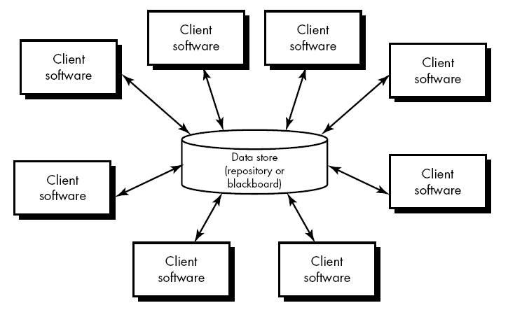

* + 1. Process Centered Approach.

In both the approaches, the other factor cannot be ignored i.e. process cannot be ignored in data centered approach and vice versa. The data centered approach starts from data structures first and then the processes and the process centric approach aim at defining all the processes first and data structure at the end. Both the approaches have their advantages and disadvantages.

We use the Data Centered approach in the design of the system. The Data-Flow Diagram and the Entity-Relationship diagram form the basic input to the design phase. The Data Centered approach is the principle of Object Oriented Design where a collection of data elements and its associated characteristics (processes) are defined as objects.

## USE CASE DIAGRAM

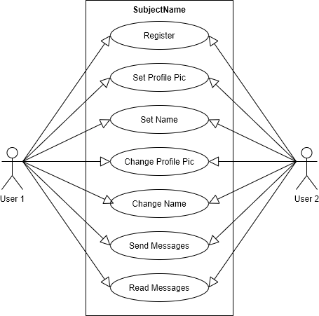

## SEQUENCE DIAGRAM

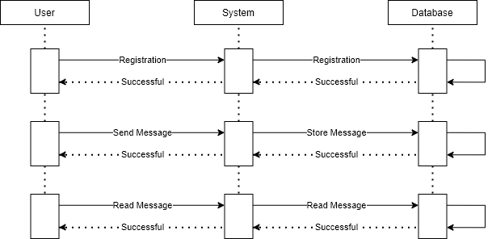

## ACTIVITY DIAGRAM

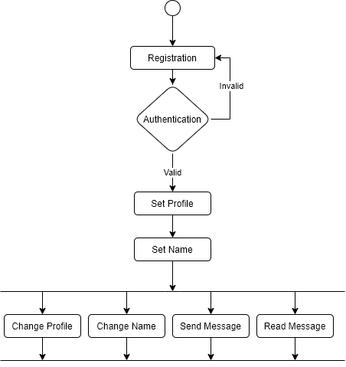

|  |  |
| --- | --- |
| **6** | **TESTING** |
| 6.1  6.2  6.3 | Testing Plans  Testing Strategies  Test Methods |

* 1. **TESTING PLAN**

#### Planning Steps

* + 1. Functionality Testing
    2. Usability testing
    3. Interface testing
    4. Security testing

#### Functionality Testing:

Test for – database connection, forms used in the activities for submitting or getting information from users, Shared Preferences Testing.

#### Check all the links:

* + Test the outgoing URLs from all the activities from specific domains under test.
  + Test all internal links.
  + Intents jumping from one activity to another.
  + Test to check if there are any orphan activities.
  + Lastly in link checking, check for broken links in all above-mentioned URLs.

#### Test forms in all pages:

Forms are the integral part of any app. Forms are used to get information from users and to keep interaction with them. So what should be checked on these forms

* + First check all the validations on each field.
  + Check for the default values of fields.
  + Wrong inputs to the fields in the forms.

#### Shared Preferences testing:

Shared Preferences are small files stored on a user's mobile. These are basically used to maintain the session mainly login sessions. Test if the Shared Preferences are encrypted before writing to the user mobile.

#### Validate your XML files:

It is very important to check if there are no visual or syntactical errors in your xml code, which can lead to malfunction of your app and can also look weird.

#### Database testing:

Data consistency is very important in an application. Check for data integrity and errors while you edit, delete, modify the data or do any DB related functionality.

Check if all the database queries are executing correctly, data is retrieved correctly and also updated correctly.

#### Usability Testing:

**Test for navigation:**

Navigation means how the user surfs the activities, different controls like buttons, boxes or how users use the links on the activities to surf different activities.

#### Content:

Content should be logical and easy to understand. Check for spelling errors. Use of dark colours annoys users and should not be used in app themes. These are common accepted standards like as I mentioned above about annoying colors, fonts, frames etc.

Content should be meaningful. All the anchor text links should be working properly. Images should be placed properly with proper sizes. These are some basic standards that should be followed in app development. Your task is to validate all for UI testing.

#### Interface Testing:

The main interfaces are:

Web server and application server interface

Application server and Database server interface.

Check if all the interactions between these servers are executed properly. Errors are handled properly. If database or web server returns any error message for any query by application server then application server should catch and display these error messages appropriately to users. Check what happens if user interrupts any transaction in-between? Check what happens if connection to web server is reset in between?

#### Security Testing

Following are the test cases for security testing:

Try to login with wrong credentials and check the message that is displayed for wrong credentials.

Try to enter wrong data into the forms, or try to leave some fields empty while filling any form and check the error message.

## TESTING STRATEGIES

#### White Box Testing:

White box testing (WBT) is also called **Structural or Glass box testing**.White box testing involves looking at the structure of the code. When you know the internal structure of a product, tests can be conducted to ensure that the internal operations performed according to the specification. And all internal components have been adequately exercised.

#### Why do we do White Box Testing?

**To ensure:**

* + That all independent paths within a module have been exercised at least once.
  + All logical decisions verified on their true and false values.
  + All loops executed at their boundaries and within their operational bounds internal data structures validity.

#### Need of White Box Testing?

**To discover the following types of bugs:**

* Logical error tend to creep into our work when we design and implement functions, conditions or controls that are out of the program
* The design errors due to difference between logical flow of the program and the actual implementation
* Typographical errors and syntax checking

#### Limitation Of WBT:

Not possible for testing each and every path of the loops in program. This means exhaustive testing is impossible for large systems.This does not mean that WBT is not effective. By selecting important logical paths and data structure for testing is practically possible and effective.

#### Black Box Testing:

* + Black box testing treats the system as a **“black-box”**, so it doesn’t explicitly use Knowledge of the internal structure or code. Or in other words the Test engineer need not know the internal working of the “Black box” or application.
  + **Main focus in black box testing is on functionality of the system as a whole.** The term **‘behavioural testing’** is also used for black box testing and white box testing is also sometimes called **’structural testing’**. Behavioural test design is slightly different from black-box test design because the use of internal knowledge isn’t strictly forbidden, but it’s still discouraged.
  + Black box testing occurs throughout the software development and Testing life cycle i.e. in Unit, Integration, System, Acceptance and regression testing stages.

#### Advantages of Black Box Testing

* + - Tester can be non-technical.
    - Used to verify contradictions in actual system and the specifications.
    - Test cases can be designed as soon as the functional specifications are complete

#### Disadvantages of Black Box Testing

* + - The test inputs needs to be from large sample space.
    - It is difficult to identify all possible inputs in limited testing time. So writing test cases is slow and difficult. Chances of having unidentified paths during this testing.

## TESTING METHODS

* Different types of testing method are used,

**UNIT TESTING:-**

* + In it analyst tests the program making up a system. The software units in a system are the modules and routines that are assembled and integrated to perform a specific function.
  + It focuses on modules, independently of one another, to locate errors. This enables the tester to detect errors in coding and logic that are contained within the module alone.

#### Bottom-Up Unit Testing:-

* + It can be performed from the bottom up, starting with the smallest and lowest-level modules and proceeding one at a time. For each module in bottom-up testing, a short program executes the module and provides the needed data, so that the module is asked to perform the way it will when embedded within the larger system.

#### Top-Down Unit Testing:-

* + As the name implies, begins with the upper-level modules. However, since the detailed activities usually performed in lower-level routines are not provided, stubs are written. A sub is a module can be called by the upper-level module and that, when reached properly, will return a message to the calling module, indicating a proper interaction occurred.

|  |  |
| --- | --- |
| **7** | **SCREENSHOTS** |
|  |  |

Splash Screen

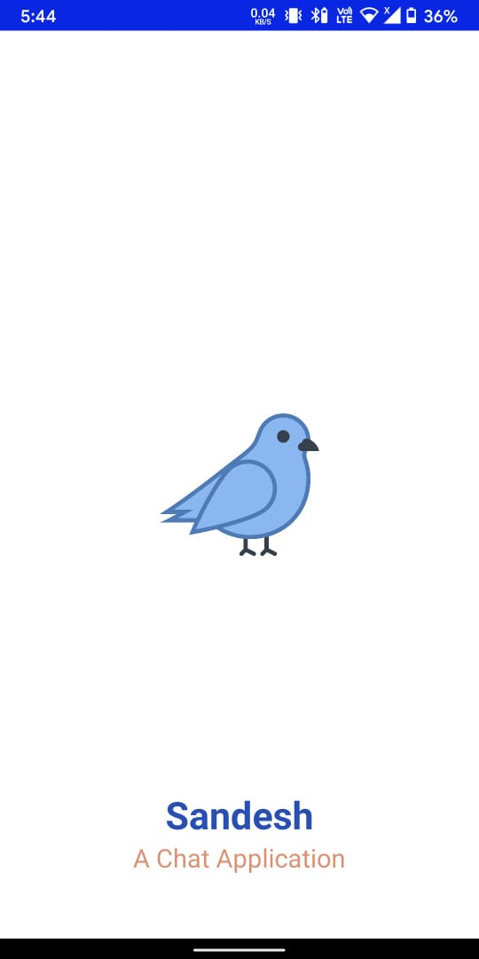

SMS Permission

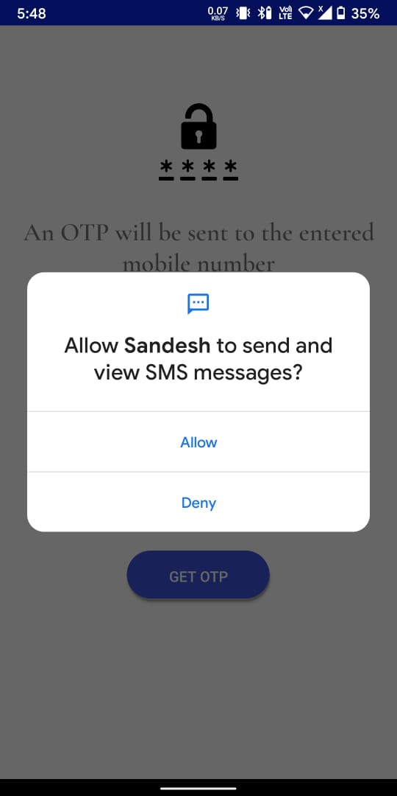

Enter user mobile number

(Along with country code picker)

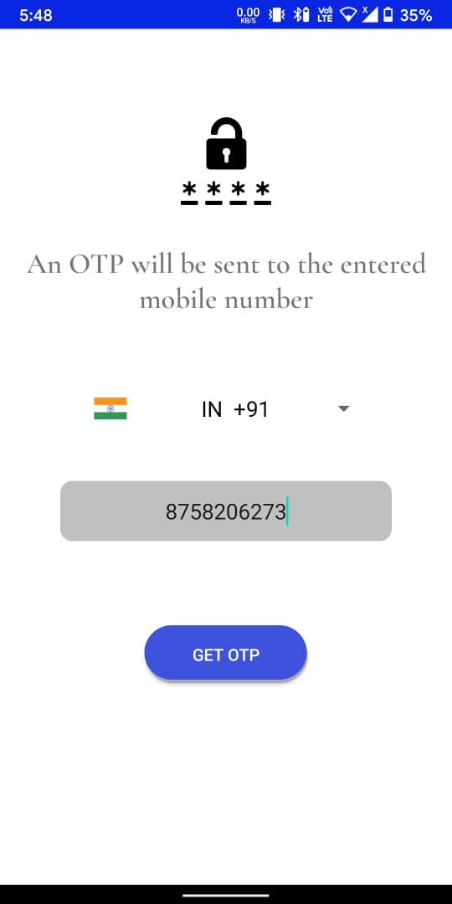

OTP Verification

(Along with automatic detection)

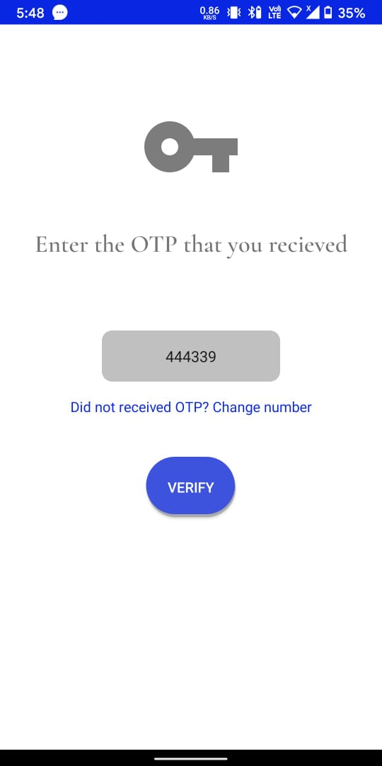

Profile Setup

Main Chat Activity

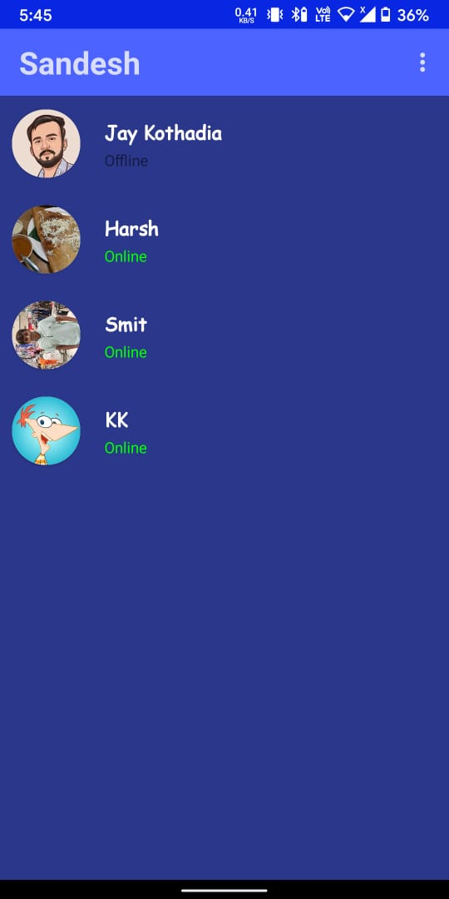

User Chat Activity

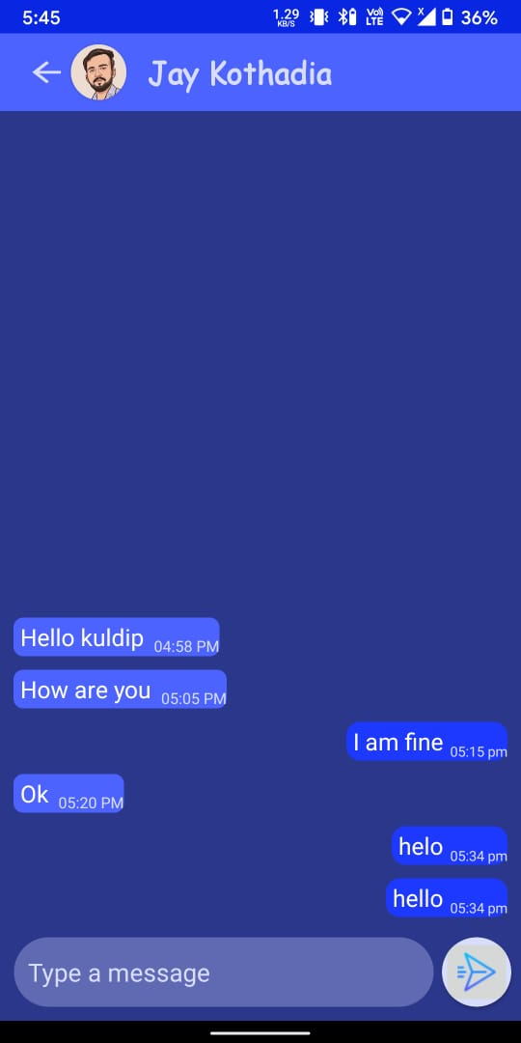

Profile Viewer

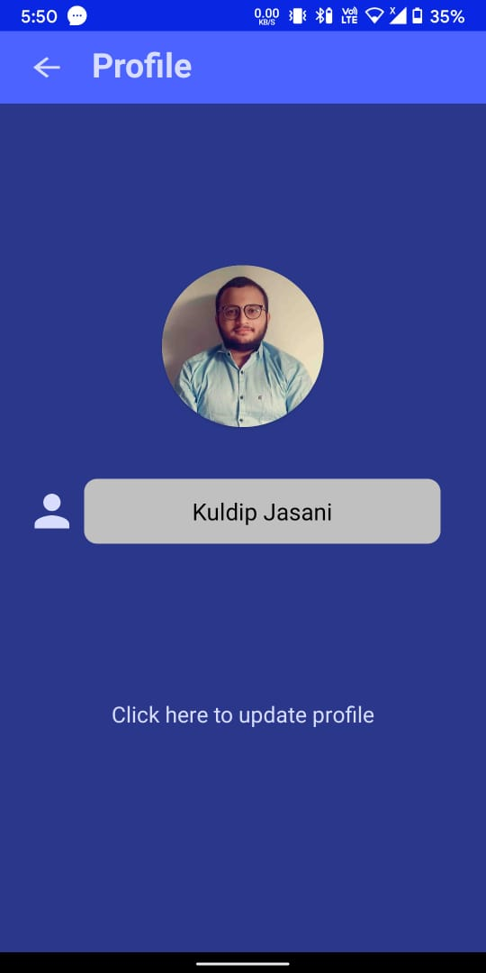

Update Profile

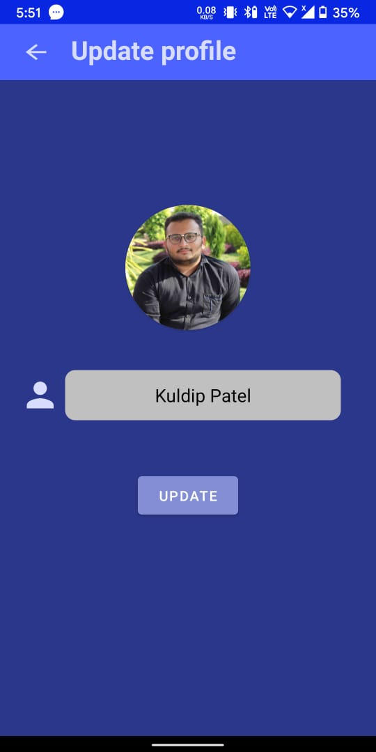

|  |  |
| --- | --- |
| **8** | **CONCLUSION** |
|  |  |

To summarize the whole project, this the sole purpose of making this app was to learn more about android development and GOOGLE FIREBASE.